1. Select the detail of the employee whose name start with P.

Output: -

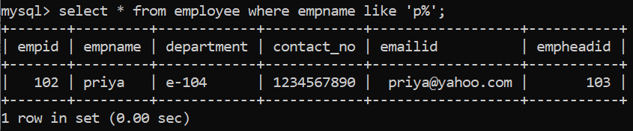

1. How many permanent candidate take salary more than 5000.

Output: -

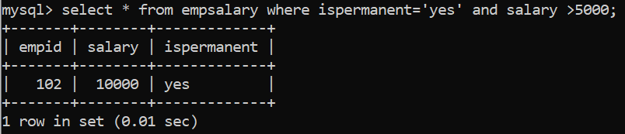

1. Select the detail of employee whose emailed is in Gmail.

Output: -

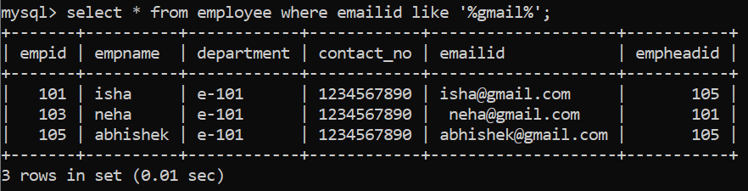

1. Select the details of the employee who work either for department E-104 or E-102.

Output: -

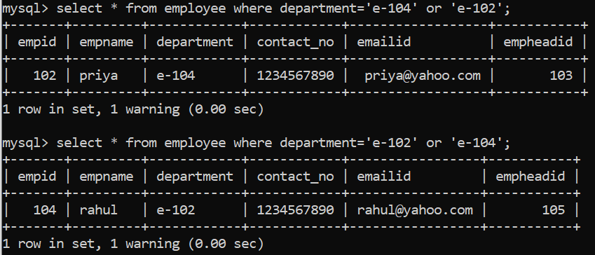

1. What is the department name for DeptID E-102?

Output: -

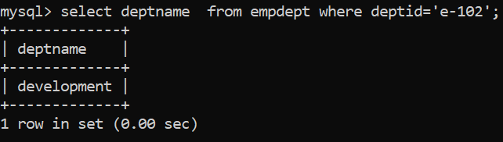

1. What is total salary that is paid to permanent employees?

Output: -

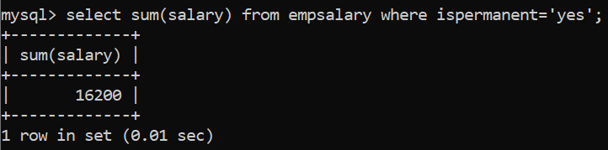

1. List name of all employees whose name ends with a.

Output: -

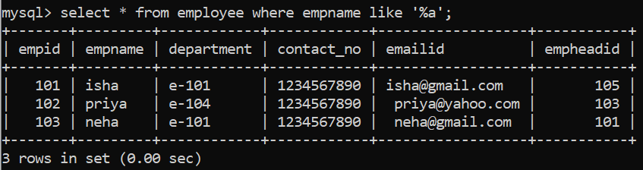

1. List the number of department of employees in each project.

Output: -

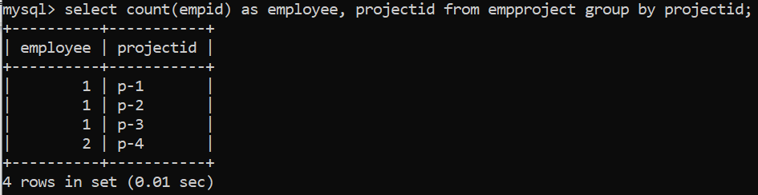

1. How many project started in year 2010.

Output: -

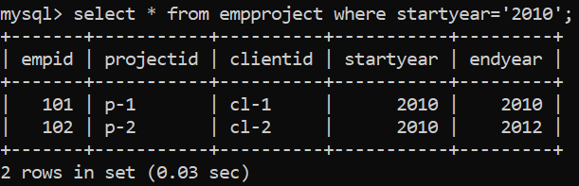

1. How many project started and finished in the same year.

Output: -

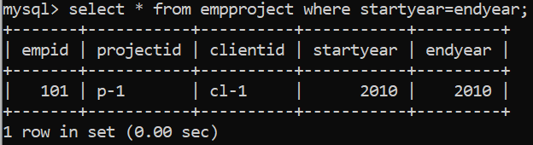

1. Select the name of the employee whose name's 3rd character is 'h'.

Output: -

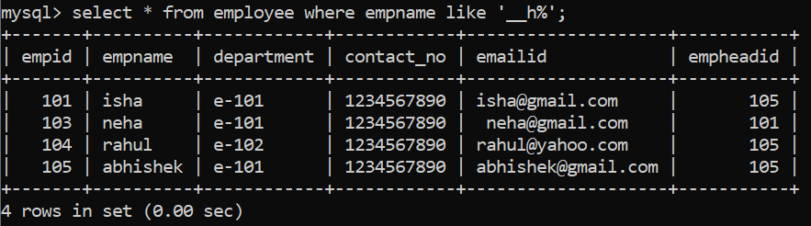

1. Select the department name of the company which is assigned to the employee whose employee id is greater 103.

Output: -

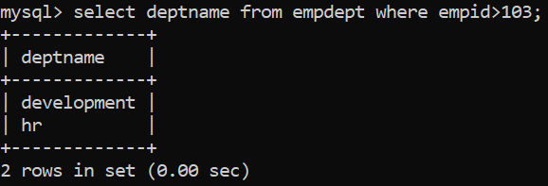

1. Select the name of the employee who is working under Abhishek.

Output: -

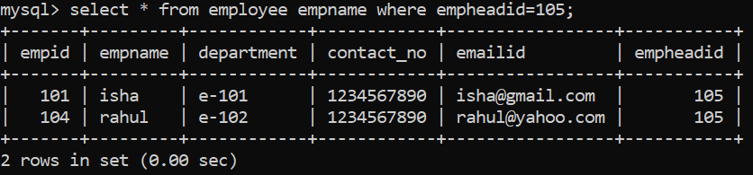

1. Select the name of the employee who is department head of HR

Output: -

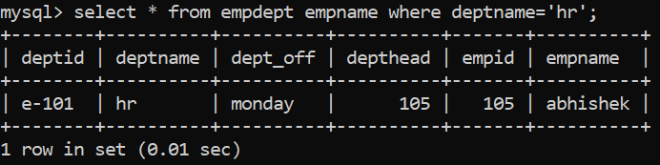

1. Select the name of the employee head who is permanent.

Output: -

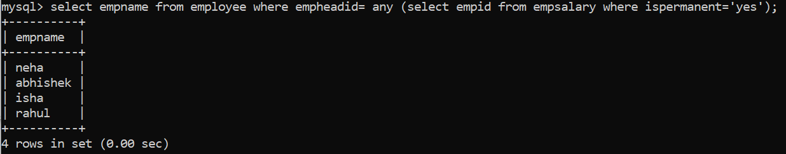

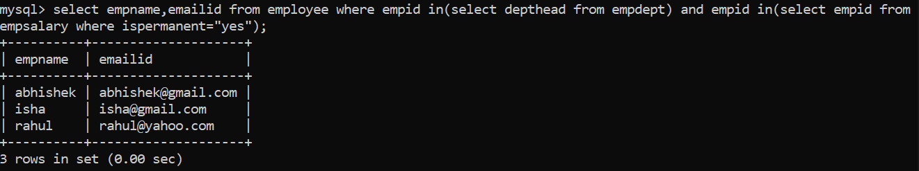

1. Select the name and email of the Dept Head who is not Permanent.

Output: -

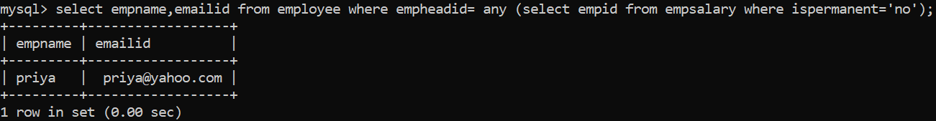

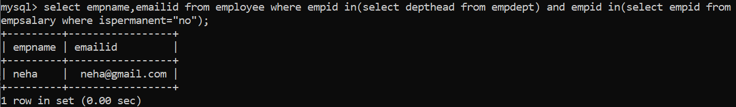

1. Select the employee whose department off is Monday

Output: -

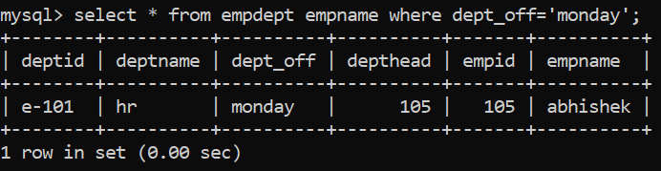

1. Select the Indian clients details.

Output: -



1. Select the details of all employee working in development department

Output: -

